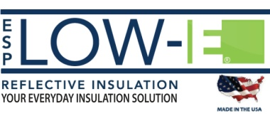
F A C T S H E E T

BACKGROUND Environmentally Safe Products Inc. (ESP) was founded in 1990. The company created and manufactures the ESP Low- E® brand of reflective insulation — a product used in the residential, commercial, industrial and agricultural building industries.

WHAT IS ESP LOW-E®? ESP Low-E® is a reflective insulation is created by heat-bonding a pure aluminum facing to closed cell non-toxic polyethylene foam. This patented process enables ESP Low-E® to outperform competing products. The product name refers to “low emissivity” — the quality that enables ESP Low-E® to work as a barrier that stops 97% of radiant heat and prevents air and moisture infiltration.

PRODUCT VERSATILITY The growth of ESP can partially be attributed to the versatility of Low-E® Reflective Insulation. The product can be used in all facets of construction: as house wrap, under slab, under roof, around ductwork, and more. It also has dozens of other applications (home, automotive, marine) wherever insulation is required.

MARKET ESP sells Low-E® insulation through a distribution network that reaches all parts of the the United States and international markets including the United Kingdom. The company sells to many of the largest production builders and remodelers in the U.S. In late 2014, the company created Simple Solution Rolls (SSR), specially packaged quantities of Low-E® for use by homeowners, car enthusiasts, and other consumers.

RECOGNITION ESP Low-E® insulation has been used in several high-profile projects, including the U.S. Capitol Dome. Because of its environmental and energy-conserving properties, ESP Low-E® was named a Top 50 product by GreenBuilder, a national trade magazine.

SCOPE ESP has produced over half a billion square feet of Low-E over the past quarter century. In 2014, the company set a record for annual revenues.

LOCATIONS The company is headquartered in New Oxford, Pennsylvania, where it operates two production facilities that serve the eastern half of the U.S., as well as Europe and South America.ESP also operates a Carson City, Nevada, manufacturing plant that produces Low-E for the western U.S. and Asia/Pacific region.

For more information, visit www.low-e.com. For media inquiries, contact David Richwine (dave@beelercommunications, 717.495.3774) or Scott Beeler (scott@beelercommunications, 717.578.9958).

